

Foundations of Programming

Assignment No.: 15
PROBLEM STATEMENT: Write a C program to generate pseudo random numbers.

OBJECTIVE:

- To understand the concept of pseudo random numbers.
- To learn the use of rand() and srand() functions in C.
- To generate random numbers using the standard library.
- To understand the role of header files in C programming.

THEORY:
In C programming, pseudo random numbers are generated using the rand() function available in the stdlib.h header file. These numbers are not truly random but are generated using a deterministic algorithm. The srand() function is used to set the seed value for random number generation. Usually, the current time is used as a seed to produce different sequences of numbers each time the program runs.

PLATFORM: Linux
ALGORITHM:
- Start
- Declare variables
  - Declare an integer n (number of random numbers)
  - Declare loop variable i
- Input
  - Ask the user to enter how many random numbers to generate
  - Read value of n
- Initialize random seed
  - Use srand(time(0)) to initialize the seed using current time
- Generate random numbers
  - Repeat steps using loop from i = 1 to n
    - Generate random number using rand()
    - Display the generated number
- End loop
- Stop

CODE:
#include <stdio.h>
#include <stdlib.h>
#include <time.h>

int main() {
int n, i;

// Input from user
printf("Enter how many random numbers you want: ");
scanf("%d", &n);

// Initialize random seed using current time
srand(time(0));

printf("Pseudo Random Numbers:\n");

// Generate random numbers
for(i = 1; i <= n; i++) {
printf("%d\n", rand());
}

return 0;
}

INPUT: Number of random numbers to be generated.

OUTPUT: Displays generated pseudo random numbers.
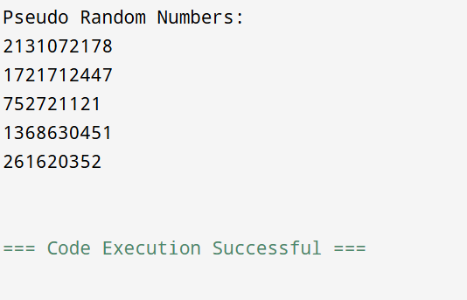

SAMPLE INPUT:
Enter how many random numbers you want: 5

SAMPLE OUTPUT:
Pseudo Random Numbers:
183746
928374
567382
345678
987234

CONCLUSION: Thus, the C program successfully generates pseudo random numbers using the rand() function and srand() for seeding.

